**Chapter 1**

**INTRODUCTION**

This database focuses on the following sectors of Library Management:

* Student Record
* Books Record
* Author Record
* Publisher Record
* Book Lending Details
* Issuing and Returning Of Books

The Admin can access the system in order to register new students, view student details, update the books catalogue, issue books to students, view all the issued books to students.

The Admin of the system acts as a communicator for the access to the system operations.

The Admin logs into to the System with the correct login credentials. The Admin can register new students, view the student details and their issued books, Admin can update new books, issue books to students and recollect the books.

**S**

**Chapter 2**

**SYSTEM REQUIREMENTS**

**Section 2.1**

**Hardware Requirements**

* Processor: Intel Core i5
* Processor Speed: 2.3 GHz
* RAM: 4GB
* Storage: 50GB

**Section 2.2**

**Software Requirements:**

* **Operating System:** Windows
* Apache Web Server (2.4.xx)
* Mysql Server
* Or XAMPP 3.2.4 (Apache and Mysql Included)
* **Web Browser :** Google Chrome/Mozilla Firefox/Internet Explorer

**Chapter 3**

**DESIGN**

**Section 3.1**

**Schema**

|  |  |  |  |  |
| --- | --- | --- | --- | --- |
| Usn | Name | Gender | Email_ID | Phone |

Student

|  |  |  |
| --- | --- | --- |
| BookId | Title | Publisher |

Books

|  |  |
| --- | --- |
| BookId | Author_Name |

Book_Author

|  |  |  |
| --- | --- | --- |
| Publisher | Phone | Address |

Publisher

|  |  |
| --- | --- |
| Usn | BookId |

Book_Lending

|  |  |  |  |
| --- | --- | --- | --- |
| BookId | Total_Books | Issued_Books | Remaining_Books |

Book_Copies

3.1 Schema Diagram

**Section 3.2**

**ER DIAGRAM**

3.2 E R Diagram

Remaining books

Issued books

Total books

Phone

Address

Publisher

PUBLISHER

PUBLISHES

BOOK_COPIES

HAS

Name

BOOKS

AUTHORED

Title

Bookid

LENDS

BOOK_AUTHOR

Author_name

STUDENTS

Phone

Gender

Email

Usn

**gg**

**Chapter 4**

**IMPLEMENTATION**

**Section 4.0**

**Login Page**

<?php

include('login.php'); // Includes Login Script

if(isset($_SESSION['login_user'])){

header("location: profile.php"); // Redirecting To Profile Page

}

?>

<!DOCTYPE html>

<html>

<head>

<title> Admin Login</title>

<link rel="stylesheet" href="/assets/css/masterlogin.css">

</head>

<body>

<div class="login-box">

<h2>Library Management Admin Login</h2> <br>

<form action="" method="post">

<label>Username :</label>

<input id="name" name="username" placeholder="enter your username" type="text">

<label>Password :</label>

<input id="password" name="password" placeholder="**********" type="password"><br><br>

<input name="submit" type="submit" value=" Login ">

<span><?php echo $error; ?></span>

</form></div>

</body>

**Section 4.1**

**Home Page**

<?php

include('session.php');

if(!isset($_SESSION['login_user'])){

// Redirecting Back To Login Page on Logging-out.

header("location: index.php"); }

?>

<meta http-equiv="content-type" content="text/html;charset=UTF-8" />

<head>

<meta charset="utf-8">

<meta http-equiv="X-UA-Compatible" content="IE=edge">

<meta name="viewport" content="width=device-width, initial-scale=1">

<meta name="description" content="Library Management,Website for CMRIT ">

<meta name="keywords" content="Library Management CMRIT, Online Courses CMRIT ">

<title> Library Management | CMRIT</title>

<link rel="shortcut icon" type="image/x-icon" href="assets/img/4.jfif">

<!-- css plugin ------------------------------------------------------------------->

<link rel="stylesheet" href="assets/css/bootstrap.min.css">

<link rel="stylesheet" href="assets/css/font-awesome.min.css">

<link rel="stylesheet" href="assets/css/magnific-popup.css">

<link rel="stylesheet" href="assets/css/flexslider.css">

<link rel="stylesheet" href="assets/css/aos.css">

<!-- main css ---------------------------------------------------------------------->

<link rel="stylesheet" href="assets/css/style.css">

<link rel="stylesheet" href="assets/css/style-responsives.css">

<!-- google fonts -------------------------------------------------------------------->

<link href="https://fonts.googleapis.com/css?family=Hind:600|Lato:300,400|Ubuntu" rel="stylesheet">

<link href="https://fonts.googleapis.com/css?family=Roboto" rel="stylesheet">

</head>

<body>

<!-- // PRELOADER BEGIN -------------------------------------------------------->

<div id="preloader">

<div id="status">

<div class="loader-revolve center">

<span></span>

</div></div></div>

<!-- // PRELOADER END ------------------------------------------------->

<!-- // NAVIGATION BEGIN---------------------------------------------->

<div id="navigation">

<div class="container">

<div class="row">

<div class="col-sm-3">

<div class="logo">

<a href="index.html" >Library Management CMRIT </a>

</div>

<!--// LOGOUT-------------------------------->

<div id="profile">

<b style="color:white" id="welcome">Welcome : <i><?php echo $login_session; ?></i></b><br>

</div>

<!-------------------------------------------->

</div>

<div class="col-sm-9">

<div class="navigation-menu">

<div class="navbar">

<div class="navbar-header">

<button type="button" class="navbar-toggle" data-toggle="collapse" data-target=".navbar-collapse">

<span class="sr-only">Toggle navigation</span>

<span class="icon-bar"></span>

<span class="icon-bar"></span>

<span class="icon-bar"></span>

</button></div>

<div class="navbar-collapse collapse">

<ul class="nav navbar-nav navbar-right">

<li><a class="active smoth-scroll" href="#particles-js">Home</a></li>

<li><a class="smoth-scroll" href="#about">Book Info.</a></li>

<li><a class="smoth-scroll" href="#portfolio">Register</a></li>

<li><a class="smoth-scroll" href="#contact">Contact</a></li>

<li><a id="logout" href="logout.php" style="color:silver">Log Out</a></li>

</ul></div></div>

</div></div></div></div></div>

<!-- // NAVIGATION END -------------------------------------------------------->

<!-- // HOME BEGIN --------------------------------------------------------------->

<div id="particles-js" class="home-bg" style="background-image: url('assets/img/2.jpg')" data-stellar-background-ratio="0.6">

<div class="overlay">

<div class="container">

<div class="row">

<div class="home-text">

<div class="profile-pic" data-aos="fade-zoom-in" data-aos-easing="ease-in-back" data-aos-delay="400"

data-aos-offset="0">

<img src="assets/img/4.jfif" />

</div>

<div data-aos="fade-zoom-in" data-aos-easing="ease-in-back" data-aos-delay="400" data-aos-offset="0">

<h1>Library Management CMRIT</h1>

<h3 id="text-rotator">

<div>Dive Deep into Concepts</div>

<div>Where Learning Never STOPS</div>

<div>CMRIT Bengaluru</div>

</h3></div></div>

<a class="smoth-scroll" href="#about"><i class="fa fa-angle-down arrow"></i></a>

</div></div></div></div>

<!-- particles-js style ----------------------------------------------------------------->

<style type="text/css" media="screen">

#particles-js

{

background-image: url('assets/img/2.jpg');

height: 100vh;

}

</style>

<!-- // HOME END -------------------------------------------------------------->

<!-- // ABOUT BEGIN --------------------------------------------------------->

<section id="about">

<div class="container">

<div class="row">

<div class="description col-md-6 col-sm-4 col-xs-12">

<h2> Welcome to our <strong style="color: #4cd137"> Library </strong></h2>

<h4> DBMS Project | CMRIT Bengaluru, India</h4>

<p> Our Project <em> ' LIBRARY MANAGEMENT ' </em> sole purpose is to build a system is to manage library daily operation efficiently.

<br></p> </div>

<div class="facts col-md-5 col-sm-5 col-xs-12">

<div class="row">

<div class="col-md-6 col-sm-6 col-xs-6">

<div class="count-item">

<div class="numscroller" data-slno='1' data-min='0' data-max='40000' data-delay='6' data-increment="50">50</div>

<div class="count-name-intro">e-Books <i class="fa fa-book"></i></div>

</div></div>

<div class="col-md-6 col-sm-6 col-xs-6">

<div class="count-item">

<div class="numscroller" data-slno='1' data-min='0' data-max='1700' data-delay='6' data-increment="2">95</div>

<div class="count-name-intro">Journals <i class="fa fa-file-text"></i></div>

</div></div></div></div></div>

</div></section>

<!-- // ABOUT END ---------------------------------------------------------------->

<section id="portfolio">

<div class="container text-center">

<div class="row">

<div class="col-md-20 text-center">

<h2> Student Registeration | Registered Student Details </h2>

</div>

<div class="col-md-18 col-sm-6">

<div class="blog-item">

<div class="blog-desc">

<h4>

<a > Student Registeration</a>

</h4>

<a href="form.html" target="_blank" class="btn btn-dark " id="register"> Student Register</a>

</div></div></div>

<div class="col-md-4 col-sm-6">

<div class="blog-item">

<div class="blog-desc">

<h4><a > Student Details</a></h4>

<a href="studentdetails.php" target="_blank" class="btn btn-dark " id="register">Student Details</a></div>

</div></div></div></div></section>

<section id="blog">

<div class="container text-center">

<div class="row">

<div class="col-md-12 text-center">

<h2>Books Available | Issue | Update </h2>

</div>

<div class="col-md-4 col-sm-6">

<div class="blog-item">

<a class="blog-img">

<img src="assets/img/7.jpg">

</a>

<div class="blog-desc">

<h4><a > Books Available</a></h4>

<p>This section contains the list of available books- currently in our CMRIT library depository.</p>

<a href="booksavailable.php" target="_blank" class="btn btn-dark" id="readmore">View</a>

</div></div></div>

<div class="col-md-4 col-sm-6">

<div class="blog-item">

<a class="blog-img">

<img src="assets/img/7.png">

</a>

<div class="blog-desc">

<h4>

<a > Book Issue/Return</a>

</h4><p>This section of Books Info. contains the list of issued/return books.</p>

<a href="booksissue.html" target="_blank" class="btn btn-dark" id="readmore">Issue</a>

<a href="reissue.html" target="_blank" class="btn btn-dark " id="register">Return</a>

</div>

</div>

</div>

<div class="col-md-4 col-sm-6">

<div class="blog-item">

<a class="blog-img">

<img src="assets/img/img3.jfif">

</a>

<div class="blog-desc">

<h4>

<a > Update </a>

</h4>

<p> Updating on the books information- i.e addition of books.</p>

<a href="update.html" target="_blank" class="btn btn-dark " id="register">Enter</a></div></div>

</div></div></div></section>

<!-- // FOOTER BEGIN -------------------------------------------------------->

<footer id="contact">

<div class="container">

<div class="col-md-12 text-center">

<h3> CONNECT WITH US.</h3>

<ul class="social-icons-footer">

<li><a href="https://twitter.com/cmritspeaks?lang=en" target="_blank"><i class="fa fa-twitter"></i></a></li>

<li><a href="https://www.linkedin.com/school/cmr-institute-of-technology/?originalSubdomain=in" target="_blank"><i class="fa fa-linkedin"></i></a></li>

<li><a href="mailto:info@cmrit.ac.in" target="_blank"><i class="fa fa-envelope"></i></a></li>

</ul></div></div></footer>

<!-- // FOOTER END ---------------------------------------------------------->

<!-- js plugin ---------------------------------------------------------------------->

<script src="assets/js/jquery.js"></script>

<script src="assets/js/bootstrap.min.js"></script>

<script src="assets/js/jquery.stellar.min.js"></script>

<script src="assets/js/text-rotate.js"></script>

<script src="assets/js/numscroller.js"></script>

<script src="assets/js/jquery.appear.js"></script>

<script src="assets/js/progress-bar.min.js"></script>

<script src="assets/js/jquery.mixitup.js"></script>

<script src="assets/js/jquery.magnific-popup.min.js"></script>

<script src="assets/js/magnific-popup-options.js"></script>

<script src="assets/js/jquery.flexslider-min.js"></script>

<script src="assets/js/aos.js"></script>

<script src="assets/js/jquery.form.js"></script>

<script src="assets/js/jquery.validate.min.js"></script>

<script src="particles.js"></script>

<script src="app.js"></script>

<!-- main js ------------------------------------------------------------------------>

<script src="assets/js/main.js"></script>

</body>

**Section 4.1.1**

**Student Register Page**

<?php

$usn = $_POST['usn'];

$username = $_POST['username'];

$gender = $_POST['gender'];

$phone = $_POST['phone'];

$email = $_POST['email'];

$password = $_POST['password'];

if (!empty($usn) || !empty($username) || !empty($gender) || !empty($phone) || !empty($email) || !empty($password)) {

$host = "localhost";

$dbUsername = "root";

$dbPassword = "";

$dbname = "library_cmrit";

//create connection

$conn = new mysqli($host, $dbUsername, $dbPassword, $dbname);

if (mysqli_connect_error()) {

die('Connect Error('. mysqli_connect_errno().')'. mysqli_connect_error());

}

else {

$SELECT = "SELECT email From student Where email = ? Limit 1";

$INSERT = "INSERT Into student values(?,?,?,?,?,?)";

//Prepare statement

$stmt = $conn->prepare($SELECT);

$stmt->bind_param("s", $email);

$stmt->execute();

$stmt->bind_result($email);

$stmt->store_result();

$rnum = $stmt->num_rows;

if ($rnum==0) {

$stmt->close();

$stmt = $conn->prepare($INSERT);

$stmt->bind_param("sssiss", $usn, $username, $gender, $phone, $email, $password);

$stmt->execute();

echo "New record inserted sucessfulsly";

}

else

{echo "Someone already register using this email";}

$stmt->close();

$conn->close();

}}

else { echo "All field are required"; die(); }

?>

**Section 4.1.2**

**Student Details Page**

<!DOCTYPE html>

<html>

<head>

<title>Student Details</title>

<style>

table {

border-collapse: collapse;

width: 100%;

color: #588c7e;

font-family: monospace;

font-size: 25px;

text-align: left;

}

th {

background-color: #588c7e;

color: white;

}

tr:nth-child(even) {background-color: #f2f2f2}

</style></head>

<body>

<table>

<tr>

<th>Usn</th>

<th>Username</th>

<th>Gender</th>

<th>Phone</th>

<th>Email</th>

</tr>

<?php

$conn = mysqli_connect("localhost", "root", "", "library_cmrit");

// Check connection

if ($conn->connect_error) {

die("Connection failed: " . $conn->connect_error); }

$sql = "SELECT * FROM student";

$result = $conn->query($sql);

if ($result->num_rows > 0) {

// output data of each row

while($row = $result->fetch_assoc()) {

echo "<tr><td>" . $row["usn"]. "</td><td>" . $row["name"] . "</td><td>" . $row["gender"] . "</td><td>" . $row["phone"] . "</td><td>"

. $row["email"]. "</td></tr>";

}

echo "</table>";

} else { echo "0 results"; }

$conn->close();

?>

</table>

</body></html>

**Section 4.1.3**

**Book Update Page**

<?php

$bookid = $_POST['bookid'];

$title = $_POST['title'];

$publisher = $_POST['publisher'];

$address = $_POST['address'];

$phone = $_POST['phone'];

$totalbooks = $_POST['totalbooks'];

$issuedbooks = 0;

$remainingbooks=$totalbooks;

if (!empty($bookid) || !empty($title) || !empty($publisher) || !empty($address) || !empty($phone) || !empty($totalbooks) ) {

$host = "localhost";

$dbUsername = "root";

$dbPassword = "";

$dbname = "library_cmrit";

//create connection

$conn = new mysqli($host, $dbUsername, $dbPassword, $dbname);

if (mysqli_connect_error()) {

die('Connect Error('. mysqli_connect_errno().')'. mysqli_connect_error());

} else {

$SELECT = "SELECT bookid From books Where bookid = ? Limit 1";

$INSERT = "INSERT Into books (bookid, title, publisher, totalbooks, remainingbooks) values(?, ?, ?, ?, ?)";

$pubinsert = " insert into publisher values(?,?,?)";

//Prepare statement

$stmt = $conn->prepare($SELECT);

$stmt->bind_param("s", $bookid);

$stmt->execute();

$stmt->bind_result($bookid);

$stmt->store_result();

$rnum = $stmt->num_rows;

if ($rnum==0) {

$stmt->close();

$stmt = $conn->prepare($INSERT);

$stmt->bind_param("sssii", $bookid, $title, $publisher, $totalbooks, $remainingbooks );

$stmt->execute();

echo "New record inserted sucessfulsly";

} else {

echo " Already registered once with this bookid";

}

$stmt->close();

$conn->close();

}}

else { echo "All field are required"; die(); } ?>

**Section 4.1.4**

**Book Issue Page**

<?php

$usn = $_POST['usn'];

$bookid = $_POST['bookid'];

if (!empty($usn) || !empty($bookid)) {

$host = "localhost";

$dbUsername = "root";

$dbPassword = "";

$dbname = "library_cmrit";

//create connection

$conn = new mysqli($host, $dbUsername, $dbPassword, $dbname);

if (mysqli_connect_error()) {

die('Connect Error('. mysqli_connect_errno().')'. mysqli_connect_error());

} else {

$SELECT = "SELECT remainingbooks From book_copies Where bookid = ? Limit 1";

$INSERT = "INSERT Into booklending (usn, bookid ) values(?, ?)";

//Prepare statement

$stmt = $conn->prepare($SELECT);

$stmt->bind_param("s", $bookid);

$stmt->execute();

$stmt->bind_result($bc);

$stmt->store_result();

$stmt->fetch();

if($bc==0){ //bc -> Book Copies

echo $bc;

echo "BOOKS not found AVAILABLE";

$stmt->close();

die();

}

else {

$stmt = $conn->prepare($INSERT);

$stmt->bind_param("ss", $usn, $bookid );

$stmt->execute();

$stmt->close();

$trigger = "update book_copies set issuedbooks=issuedbooks+1 where bookid = ?";

$stmt = $conn->prepare($trigger);

$stmt->bind_param("s", $bookid);

$stmt->execute();

echo "New record inserted sucessfulsly";

$conn->close();

}}

}

else { echo "All field are required"; die(); } ?>

**Section 4.1.5**

**Book Return Page**

<?php

$usn = $_POST['usn'];

$bookid = $_POST['bookid'];

if (!empty($usn) || !empty($bookid)) {

$host = "localhost";

$dbUsername = "root";

$dbPassword = "";

$dbname = "library_cmrit";

//create connection

$conn = new mysqli($host, $dbUsername, $dbPassword, $dbname);

if (mysqli_connect_error()) {

die('Connect Error('. mysqli_connect_errno().')'. mysqli_connect_error());

} else {

$INSERT = "Delete from booklending where usn=? and bookid= ? ";

$stmt = $conn->prepare($INSERT);

$stmt->bind_param("ss", $usn, $bookid );

$stmt->execute();

$stmt->close();

$trigger = "update book_copies set issuedbooks=issuedbooks-1 where bookid = ?";

$stmt = $conn->prepare($trigger);

$stmt->bind_param("s", $bookid);

$stmt->execute();

echo "New record inserted sucessfulsly";

$conn->close();

}}

else {echo "All field are required"; die(); } ?>

**Section 4.1.6**

**Books Available Page**

<!DOCTYPE html>

<html>

<head>

<title>Books Available</title>

<style>

table {

border-collapse: collapse;

width: 100%;

color: #588c7e;

font-family: monospace;

font-size: 25px;

text-align: left;

}

th { background-color: #588c7e; color: white; }

tr:nth-child(even) {background-color: #f2f2f2}

</style>

</head>

<body>

<table>

<tr>

<th>Book Id</th>

<th>Book Title</th>

<th> Book Author </th>

<th> Total Books </th>

<th> Issued Books </th>

<th> Remainig Books </th>

<th> Book Publisher</th>

<th> Phone_no </th>

</tr>

<?php

$conn = mysqli_connect("localhost", "root", "", "library_cmrit");

// Check connection

if ($conn->connect_error) {

die("Connection failed: " . $conn->connect_error);

}

$sql = "call find2()"; //stored procedure

$result = $conn->query($sql);

if ($result->num_rows > 0) {

// output data of each row

while($row = $result->fetch_assoc()) {

echo "<tr><td>" . $row["bookid"]. "</td><td>" . $row["title"] . "</td><td>" . $row["author_name"]. "</td> <td>" . $row["totalbooks"]. "</td><td>" . $row["issuedbooks"]. "</td><td>" . $row["remainingbooks"]. "</td><td>"

. $row["publisher"]. "</td><td>". $row["phone"]. "</td></tr>";

}

echo "</table>";

} else { echo "0 results"; }

$conn->close();

?>

</table>

</body> </html>

**Section 4.2**

**Trigger and Stored Procedure**

**Section 4.2.1**

**Stored Procedure**

DELIMITER $$

CREATE PROCEDURE `find2` () BEGIN

SELECT b.bookid,b.title,b.publisher,ba.author_name,c.totalbooks,c.issuedbooks,c.remainingbooks,p.phone from books b,book_copies c,book_author ba,publisher p where b.bookid=ba.bookid and b.bookid=c.bookid and b.publisher=p.publisher;

END$$

DELIMITER ;

**Section 4.2.2**

**Triggers**

Triggers `book_copies`

------------------------------------------------------------------------------------------------

DELIMITER $$

CREATE TRIGGER `rem_book2` BEFORE UPDATE ON `book_copies` FOR EACH ROW set new.remainingbooks=new.totalbooks-new.issuedbooks

$$

DELIMITER ;

------------------------------------------------------------------------------------------------

**Chapter 5**

**DISCUSSION AND SCREENSHOTS**

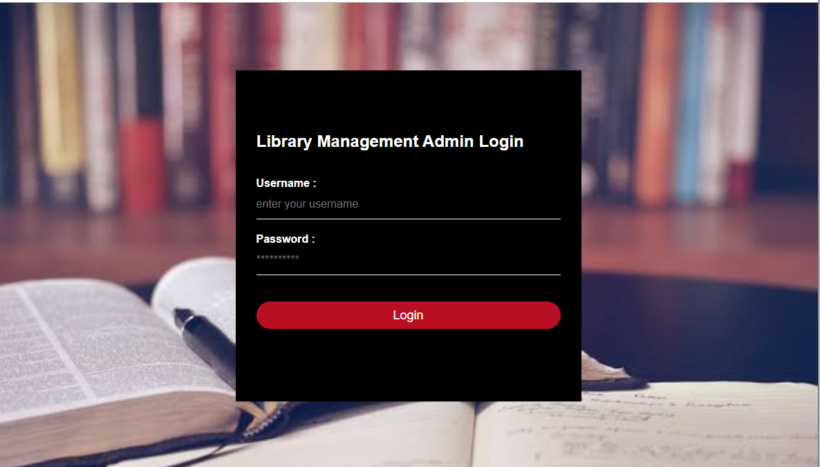

**5.0 Login Page**



**5.1 Home Page**

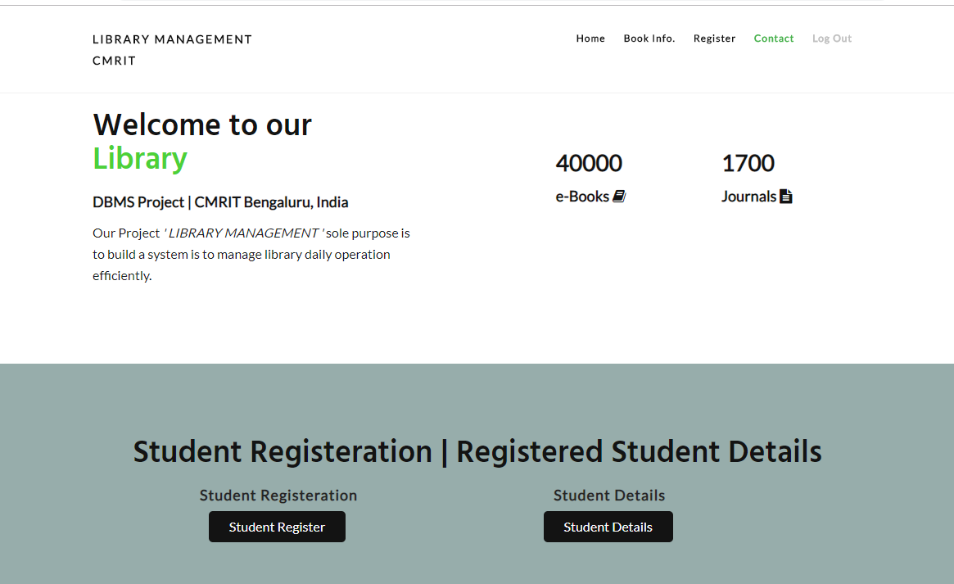

**5.2 Student Register & Details Section**

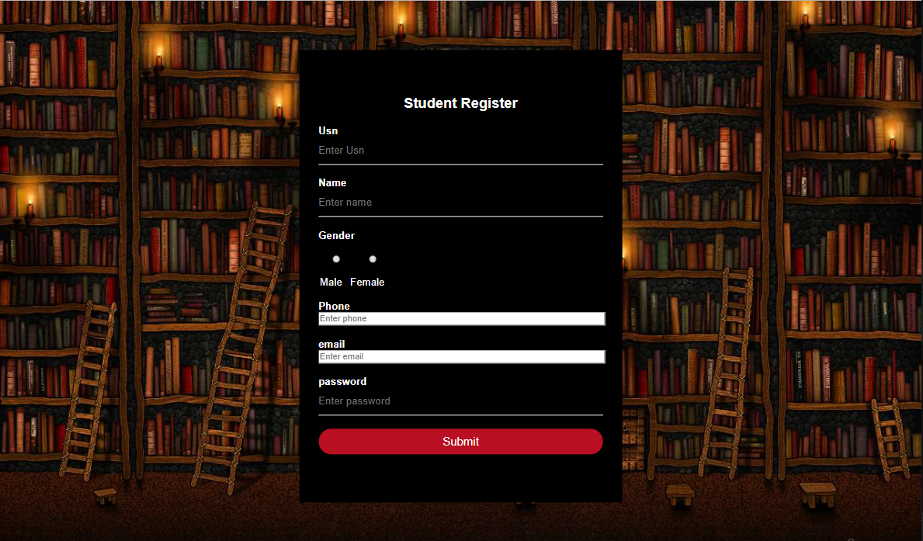**5.2.1 Student Register Page**

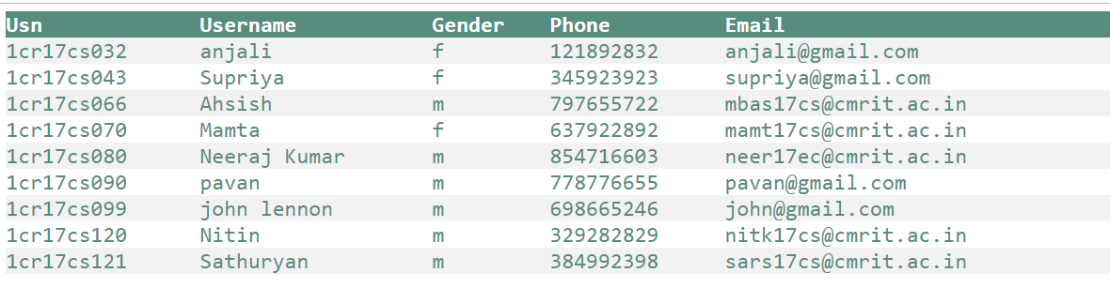**5.2.2 Student Details Page**



**5.3 Books Info. Section**

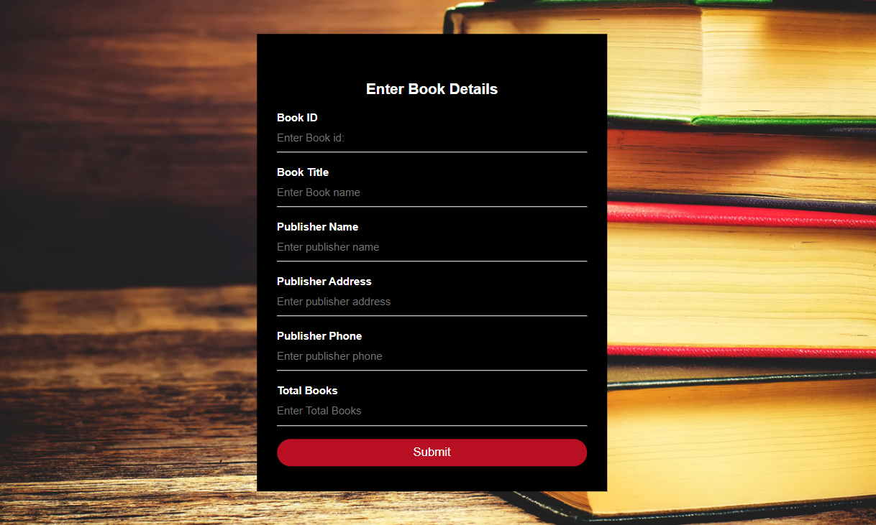

**5.3.1 Enter Book Details Page**

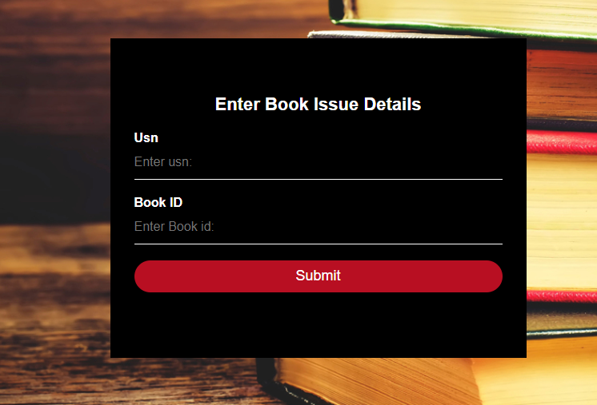 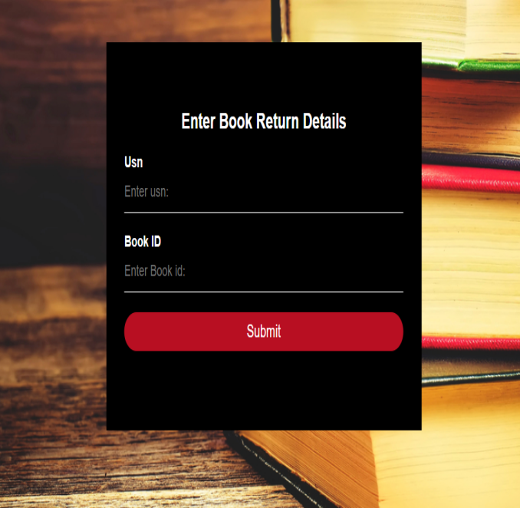

**5.3.2 Book Issue Page & 5.3.3 Book Return Page**

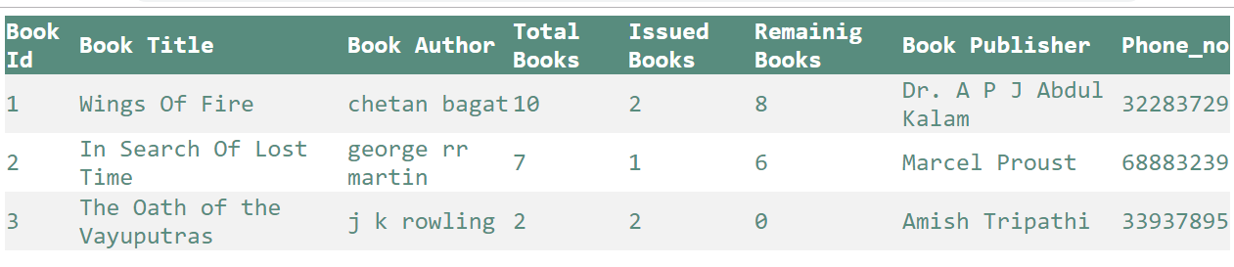

**5.4 Book Available Page**

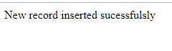

**5.5 Successfully Inserted Page**

**Chapter 6**

**CONCLUSION AND FUTURE SCOPE**

**Section 6.1**

**Conclusion**

This report has discussed the development of a stand-alone application that allows a Librarian to register students to register new students, view student details, update the books catalogue, issue books to students and view all issued books to students.

An Admin Login is provided to manage the Library Management for the desired purpose.

**Section 6.2**

**Future Scope**

This project has the ability to maintain a simple Library Management System through authorized personnel which can later be automated.

We can have a general Library Management for Transaction on Book-issue and use a simple desktop application or a web app to access everything making it convenient and simple for everyone.

**REFERENCES**

1. <http://www.mysqltutorial.org>
2. <https://stackoverflow.com/>
3. [https://w3schools.com/](https://docs.oracle.com/java)